**Project Design Phase-II Technology Stack (Architecture & Stack)**

|  |  |
| --- | --- |
| Date | 04 November 2022 |
| Team ID | PNT2022TMID34443 |
| Project Name | Customer Care Registry |
| Maximum Marks | 4 Marks |

**Technical Architecture:**

**Table-1 :** 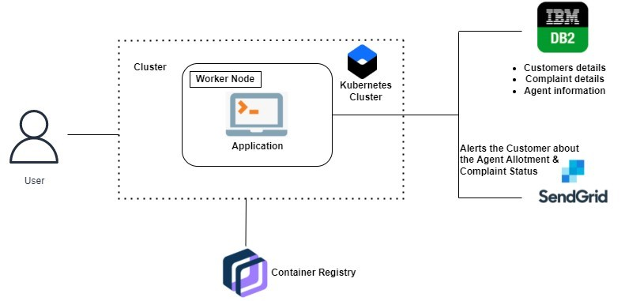

**Components & Technologies:**

|  |  |  |  |
| --- | --- | --- | --- |
| **S.No** | **Component** | **Description** | **Technology** |
| 1. | User Interface | Web UI | HTML,CSS,JavaScript |
| 2. | Backend Language | Server-side implementation | Python |
| 3. | Virtual Assistant | Chat Bot | IBM Watson Assistant |
| 4. | Cloud Database | Database Service on Cloud | IBM DB2, IBM Cloudant etc. |
| 5. | File Storage | File storage requirements | IBM Block Storage |
| 6. | Containerization | Docker Container | IBM Container Registry |
| 7. | Infrastructure (Cloud) | Application Deployment on Cloud | Kubernetes |